Parbon

UNDERGRADUATE PROJECT

Submitted in partial fulfillment of the requirements of software development project 2 for the degree of

B.Sc. Engg. In CSE

**By**

**GROUP: AN0NYMOU5**

**UNDER SUPERVISION OF:**

Dipu Akter Shila

Teaching Assistant, Dept. of CSE

Bangladesh University of Business and Technology



BANGLADESH UNIVERSITY OF BUSINESS & TECHNOLOGY (BUBT)

Dhaka-1216

March 2021

Parbon

Group Member List

* Ahmed Mahir Shoaib (18192103235)
* Abu Zobayer Bin Siddique (18192103226)
* All Moon Tasir (18192103256)

***Declaration of Authorship***

We, Ahmed Mahir Shoaib, Abu Zobayer Bin Siddique and All Moon Tasir declare that this project titled, ”Parbon” and the work presented in it are our own. We confirm that:

This work was done wholly or mainly while in candidature for a B.Sc. Engineering in CSE degree at this University.

* Where any part of this software development project has previously been submitted for a degree or any other qualification at this University or any other institution, this has been clearly stated.
* Where we have consulted the published work of others, this is always clearly attributed.
* Where we have quoted from the work of others, the source is always given. With the exception of such quotations, this thesis is entirely our own work.
* We have acknowledged all main sources of help.
* Where the thesis is based on work done by ourselves jointly with others, we have made clear exactly what was done by others and what we have contributed myself.

Ahmed Mahir Shoaib Abu Zobayer Bin Siddique

ID: 18192103235 ID: 18192103226

Date: Date:

All Moon Tasir

ID:

Date:

Certificate

This is to certify that the project entitled “Parbon” and submitted by Ahmed Mahir Shoaib, Abu Zobayer Bin Siddique, All Moon Tasir ID No. 18192103235, 18192103226. 18192103256 in partial fulfillment of the requirements of embodies the work done by them under my supervision.

***Dipu Akter Shila***

Teaching Assistant, Department of CSE

Bangladesh University of Business and

Technology

Date:

***Dedication***

Dedicated to our parents for all their love and inspiration.

***Abstract***

We basically get all the services around through the app. So we thought that if we can bring the catering service in the app, then the hassle of organizing any event for everyone will be reduced and the facilities will be easily available. So we have chosen this project.

Acknowledgements

First of all, we are thankful and expressing our gratefulness to Almighty Allah who offers us His divine blessing, patient, mental and physical strength to complete this project work.

We are deeply indebted to our project supervisor Dipu Akter Shila, Teaching Assistant, Department of Computer Science and Engineering (CSE), Bangladesh University of Business and Technology (BUBT). His scholarly guidance, important suggestions, work for going through our drafts and correcting them, and generating courage from the beginning to the end of the research work has made the completion of this thesis possible.

A very special gratitude goes out to all our friends for their support and help to implement our works. The discussions with them on various topics of our works have been very helpful for us to enrich our knowledge and conception regarding the work.

Last but not the least; we are highly grateful to our parents and family members for supporting us spiritually throughout writing this thesis and our life in general.

Approval

This project “Parbon” Submitted by Ahmed Mahir Shoaib, Abu Zobayer Bin Siddique, All Moon Tasir, ID: 18192103235, 18192103226, 18192103256. Department of Computer Science and Engineering (CSE), Bangladesh University of Business and Technology (BUBT) under the supervision of Md. Ariful Islam Malik; Lecturer, Department of Computer Science and Engineering has been accepted as satisfactory for the partial fulfillment of the requirement for the degree of Bachelor of Science (B.Sc. Engg.) in Computer Science and Engineering and approved as to its style and contents.

Supervisor:

Dipu Akter Shila

Teaching Assistant

Department of CSE.

Bangladesh University of Business and Technology (BUBT)

Chairman:

Dr. Md. Firoz Mridha

Associate Professor and Chairman

Department of CSE

Bangladesh University of Business and Technology (BUBT)

Contents:

Chapter 1:

* Introduction 11

Chapter 2:

* 2.1: Project Review 12
* 2.2 Parbon database and DBMS 12
* 2.3 Advantage of DBMS 13
* 2.4 Client Record and Database 14

Chapter 3:

* 3.1 System analysis and development life cycle 15

Chapter 4:

Technology

* Software: 17
* Language: 18
* Operating System: 18

Chapter 5:

* Design, Database And System analysis: 19

Chapter 6:

Ending

* Future Plan and Conclusion 31
* Reference 32

List of Figure:

1. Project Development Phase 14
2. System Development Life Cycle 17
3. ERD 21
4. Home page 22
5. Sign Up Page 22
6. Account create 23
7. Saved in Database 23
8. Confirmation mail 23
9. Admin Login 24
10. User Log in 25
11. Catering service list 26
12. Community Center List 26
13. Decorator List: 27
14. Particular Catering Details (Desh Catering) 28
15. Wedding Stage 29
16. Wedding Stage Details 29
17. Holud Stage 30
18. Bed Decoration Package 30
19. Khatna Stage 31
20. Birthday Stage 31
21. Booking Package 32
22. Information For Booking 32
23. Database For Saving Information 32
24. Package Saved in Database 32

Chapter 1:

Introduction:

Parbon is a catering service. Mainly this is a console based application. At present we are busy with a lot of work around us in any event. In that case, renting a community center or restaurant is another added stress for us. Also whichever I can afford would be better, again at a short distance from my home. With all that in mind, if we could get an advantage where someone would do all these things for me, how much better it would be.

We are currently moving forward through applications or using online services. We have to go somewhere, no matter how many ride sharing applications there are. Tickets need to be booked. It doesn't matter, there are many online platforms. Even in the agony of hunger, there is Foodpanda or any other applications.

After looking this type of applications in the vicinity we think if we can create something that is a new concept in the context of our country. Parbon is the manifestation of this thought.

With this application, users can easily rent a community center or restaurant from home. Also be able to choose the food according to his choice. Also, he can give full responsibility to any catering service. Not only that, if anyone wants, he can rent catering service for organizing any event in his own house. Or suppose someone lives in Dhaka, he is organizing an event in his own house. But since there are not so many cooking facilities in his house, in that case he may be limited to ordering food only. Assuming again, I live in Pabna, now I want to organize an event in Noakhali or Kushtia and want to take the catering service to my area. In that case it is possible to contact them through the application and take them to another place with the consent of the user.

We are very optimistic about this application, it will be much more beneficial for people and will achieve considerable success for a business purpose.

Chapter 2:

2.1 Project Review:

Project management skills are put to good use for this project. Having gone through project management modules in Time Series Analysis, Optimization and with two interns Project Management for Business and IT respectively, they enhanced my knowledge on managing a project. Project management focuses on achieving the objectives by applying five processes presented in Figure below.

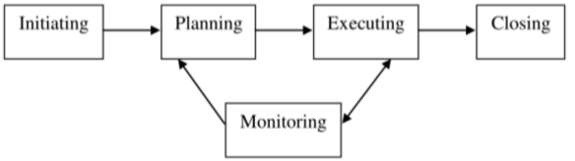

This is our project development phase.

2.2 Parbon Database and Database Management System:

A database is an integrated collection of data, usually so large that it has to be stored on secondary storage devices such as disks or tapes. This data can be maintained as a collection of operating system files, or stored in a DBMS (database management system). A Database Management System (DBMS) is computer software designed for the purpose of managing databases based on a variety of data models. A DBMS is a complex set of software programs that controls the organization, storage, management, and retrieval of data in database. DBMS are categorized according to their data structures or types, sometime DBMS is also known as Database Manager. It is a set of pre written programs that are used to store, update and retrieve a Database. When a DBMS is used, information systems can be changed much more easily as the organization’s information requirements change. New categories of data can be added to the database without disruption to the existing system. Organizations may use one kind of DBMS for daily transaction processing and then move the detail onto another computer that uses another DBMS better suited for random inquiries and analysis.

2.3 Advantages of DBMS

• Improved strategic use of corporate data

• Reduced complexity of the organization’s information systems environment

• Reduced data redundancy and inconsistency

• Enhanced data integrity

• Application-data independence

• Improved security

• Reduced application development and maintenance costs

• Improved flexibility of information system

• Increased access and availability of data and information

• Logical Physical data independence

• Concurrent access anomalies.

• Facilitate atomized problem.

• Provides central control on the system through DBA.

2.4 Client Record and Database:

This database is used so that the client is not disadvantaged by using our app. Also keep track of whether customers and sellers are failing to receive their services at the right time through the admin. Advantage of this Database are given below:

* Managing the relation between customer and seller.
* Notifying them about their event.
* Control all event from admin panel

We will have all the information of the client in our database. Whether he is a customer or a seller. As a result, we will be able to take immediate action if any untoward situation occurs at any time. Also, since our database will contain all the necessary information, so the client will be able to keep track of the progress of his / her work at any time by looking at the information he / she has ordered. The advantage of our database system is given below:

* Any client can know about his order using our app.
* They will no longer have to worry about organizing their event.
* If someone is a fraud here, they will be easily caught. Because their NID card number will be in our database. As a result, the app will be much more secure.
* None of our information will be directly in the code, it will be in the database. As a result, it will be more difficult for hackers to hack our information than before.

Chapter 3

Resources

3.1 System Development life cycle:

Systems Development Life Cycle (SDLC) is the most common process adopted to develop a project and not surprisingly, this project is following this model too. To be precise, waterfall model is being applied. Waterfall model is a sequential model process where the input of a phase actually results from the previous phase.

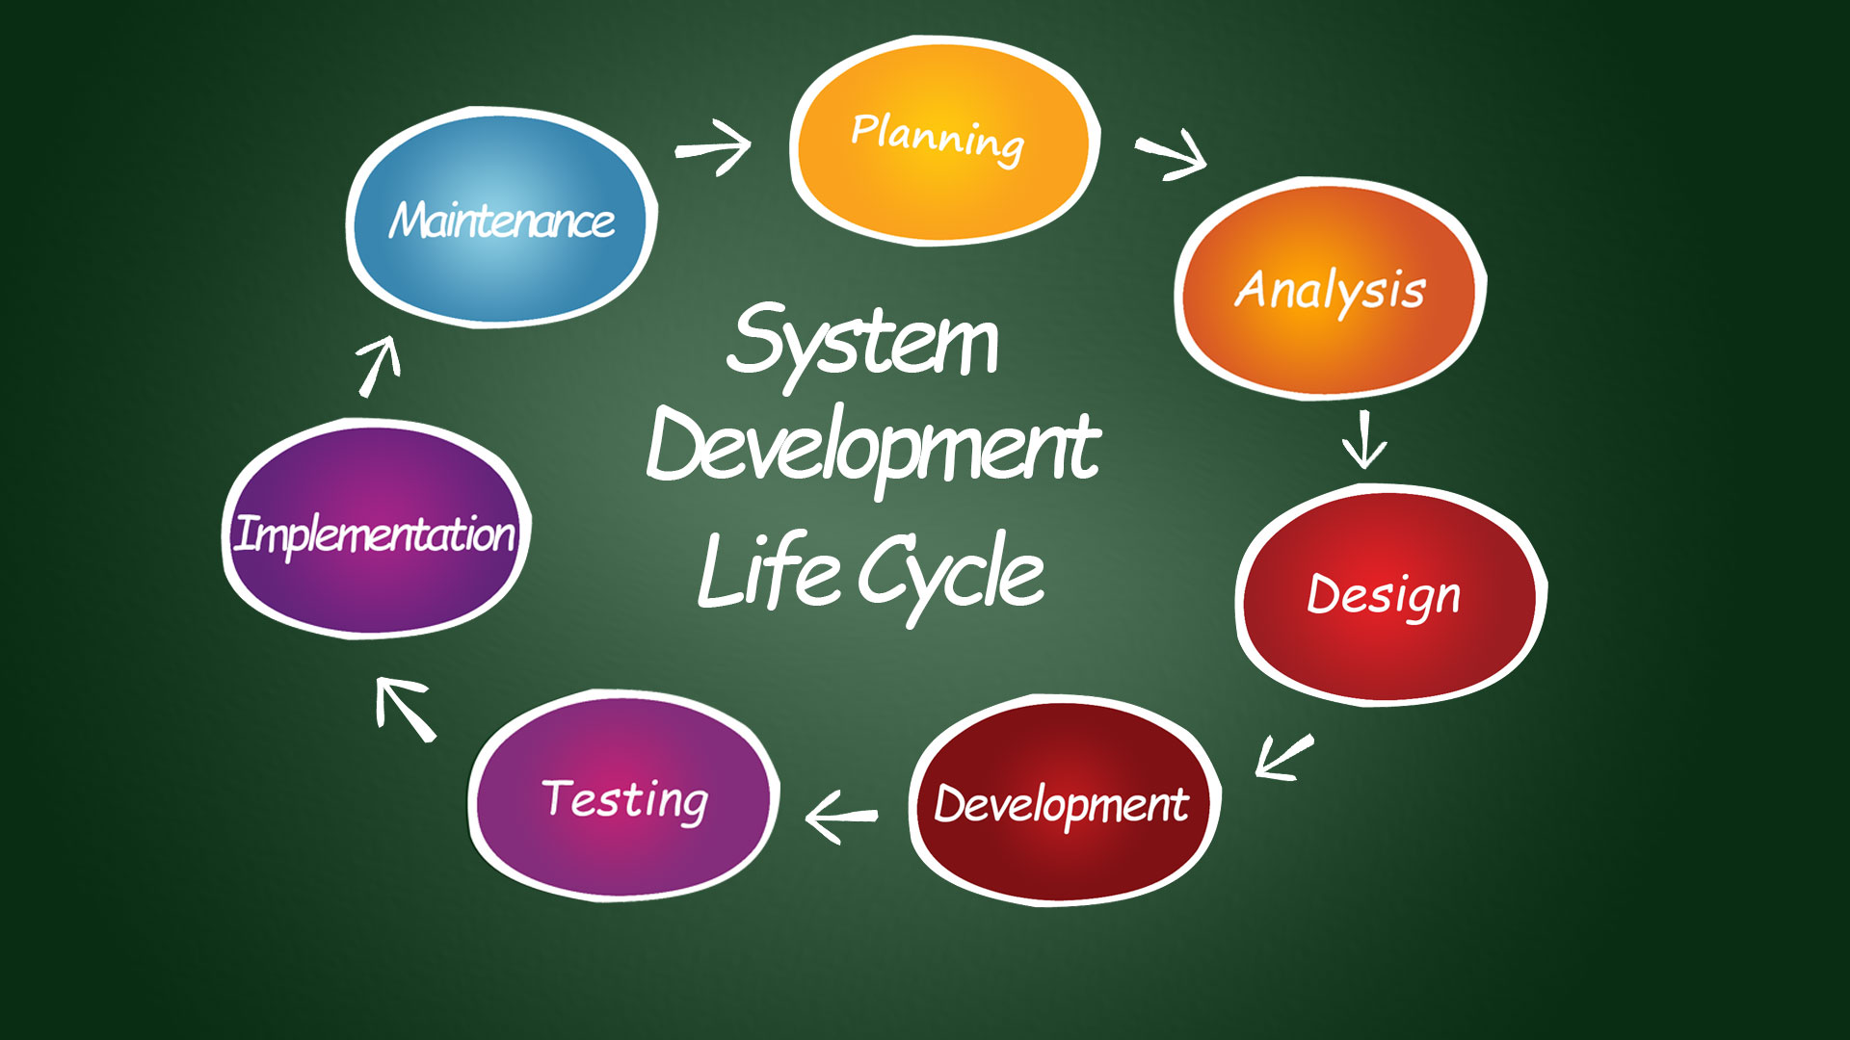

There are seven step in this software. Number one is planning. We first discuss one thing in the presence of all our teammates, what kind of project we should create.

Then in the second step or analysis stage we think about what it might take us to complete this project. There we make a draft of our project.

In third stage, then we follow some different algorithms. From there we come to the conclusion that how to design at any step.

Then in fifth step we start developing the project code, and we also started working for the database.

Then we go to the testing part. In this stage, we check if there are any bugs in our code with some random input.

If in testing part we find any bug, we were fix them.

Then we maintain this app. Even then, whenever there is a problem, we immediately repeat the process in the same way.

Chapter 4

Technologies:

Software:

***Visual Studio:*** Microsoft Visual Studio is an integrated development environment (IDE) from Microsoft. It is used to develop computer programs, as well as websites, web apps, web services and mobile apps. Visual Studio uses Microsoft software development platforms such as Windows API, Windows Forms, Windows Presentation Foundation, Windows Store and Microsoft Silverlight. It can produce both native code and managed code. Visual Studio includes a code editor supporting IntelliSense (the code completion component) as well as code refactoring. The integrated debugger works both as a source-level debugger and a machine-level debugger. Other built-in tools include a code profiler, designer for building GUI applications, web designer, class designer, and database schema designer. It accepts plug-ins that expand the functionality at almost every level—including adding support for source control systems (like Subversion and Git) and adding new toolsets like editors and visual designers for domain-specific languages or toolsets for other aspects of the software development lifecycle (like the Azure DevOps client: Team Explorer). Visual Studio supports 36 different programming languages and allows the code editor and debugger to support (to varying degrees) nearly any programming language, provided a language-specific service exists. Built-in languages include C, C++, C++/CLI, Visual Basic .NET, C#, F#, JavaScript, TypeScript, XML, XSLT, HTML, and CSS. Support for other languages such as Python, Ruby, Node.js, and M among others is available via plug-ins. Java (and J#) were supported in the past.

***Xampp:*** XAMPP is a free and open-source cross-platform web server solution stack package developed by Apache Friends, consisting mainly of the Apache HTTP Server, MariaDB database, and interpreters for scripts written in the PHP and Perl programming languages. Since most actual web server deployments use the same components as XAMPP, it makes transitioning from a local test server to a live server possible. XAMPP's ease of deployment means a WAMP or LAMP stack can be installed quickly and simply on an operating system by a developer, with the advantage that common add-in applications such as WordPress and Joomla! can also be installed with similar ease using Bitnami.

MySql Community: MySQL Community Edition is a freely downloadable version of the world's most popular open source database that is supported by an active community of open source developers and enthusiasts.

GitBash: Using This software, we share our file in github.

Github: Using this website we share our file with each other.

Language:

This software is designed by C# and here we use .net framework.

Operating System:

* Windows 10
* Windows 8.1
* Ubuntu

Chapter 5

Design, Database & System Analysis:

s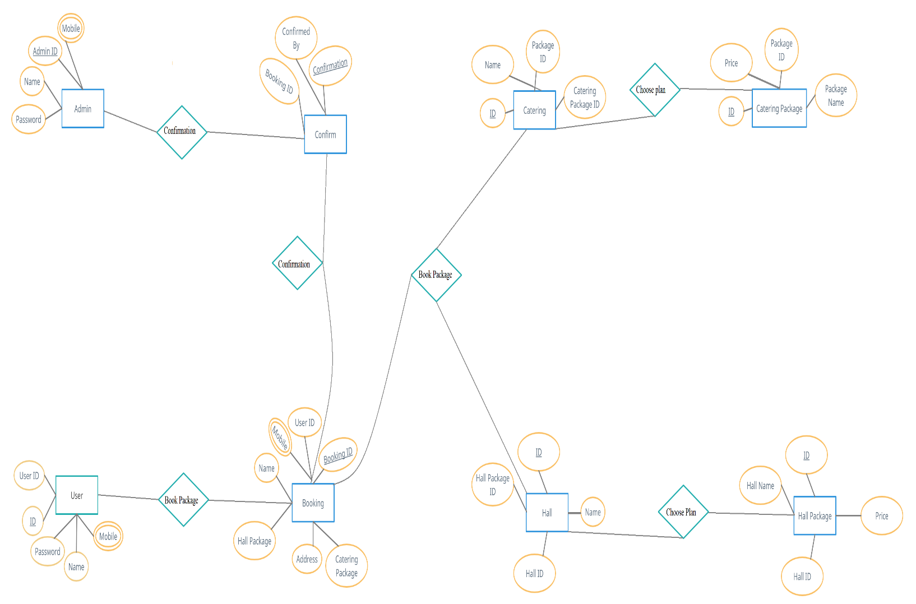

<https://github.com/amsaabesh/SDP-2-Parbon/blob/main/Report/picture/ERD%20(2).png> (link of this erd)

Home Page:

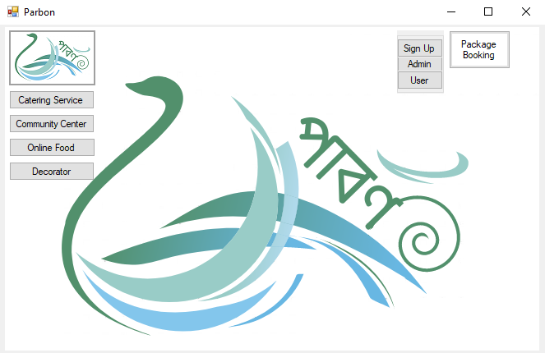

This is the layout of home page. You can create account or log in from here. You will find all categories of our project in this page. If you click to the sign up,

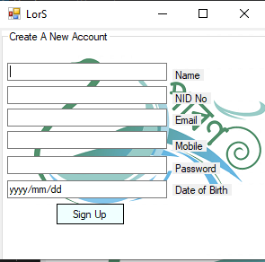

This page will come in front of you. After that, if you press the “Sign Up” button with the information, the registration will be done and a confirmation mail will send in your given email. Sign up Confirmation message, Information in Database and confirmation mail picture is given serially below.

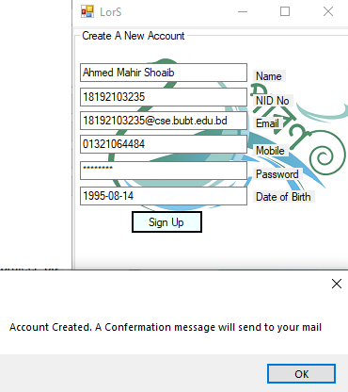

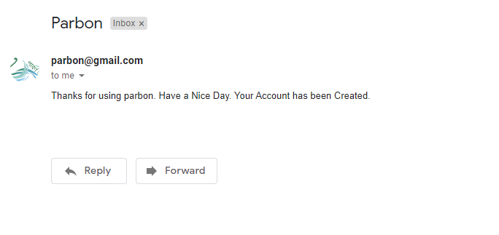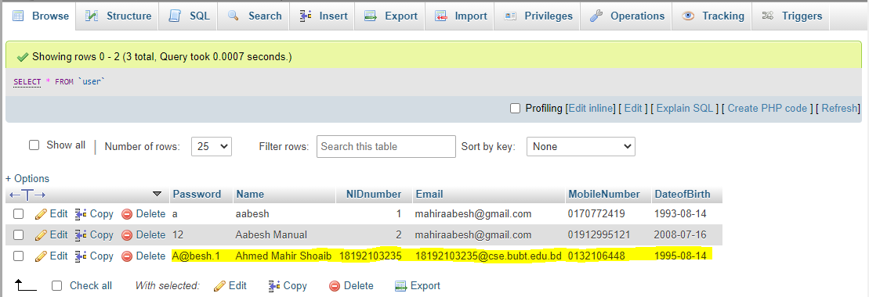

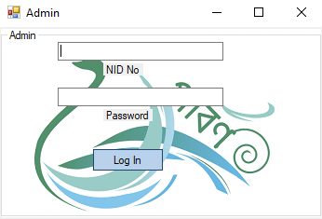

Then if you click the Admin or log in button from Home page

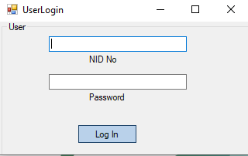

You will see this page. These two pages are quite similar.

From Community Center, Catering service and decorator page, you can book any of their package. The Picture of those page are given below:

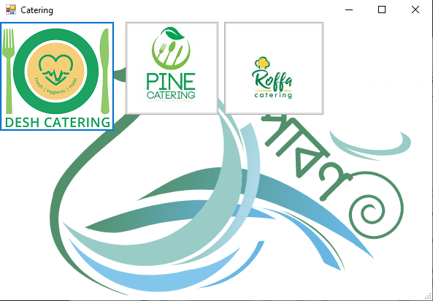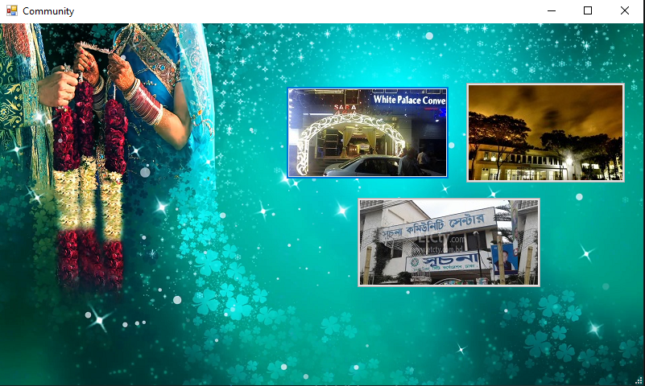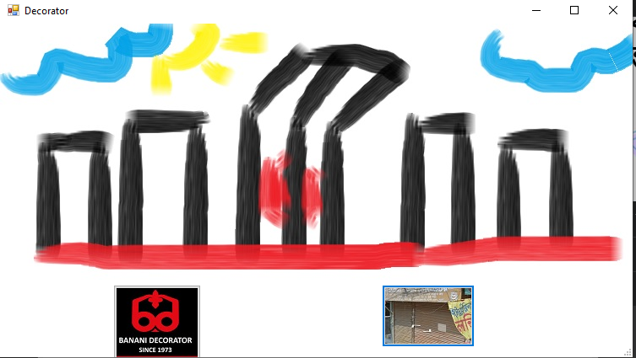

From the first image, if you click any of this catering service, you can see their packages

.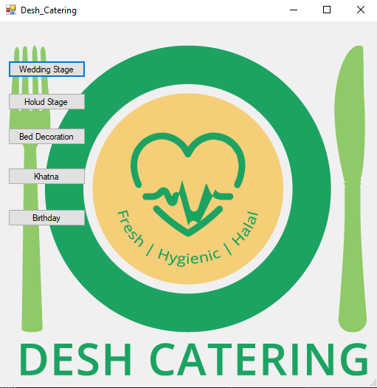

Then if you click any of this package, you will able to see all of their items. This pictures are given below

.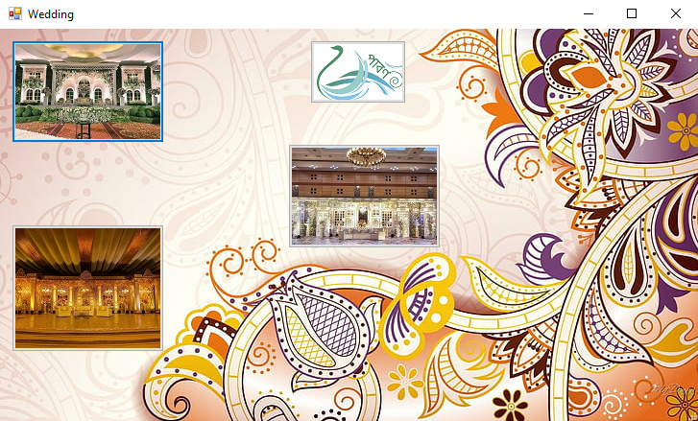

Then if you click on any stage, you will see the price and full package of it.

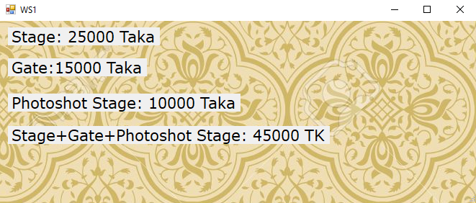

Similarly Holud, Bed Decoration, Khatna and Birthday Package are same. This pictures are given below.

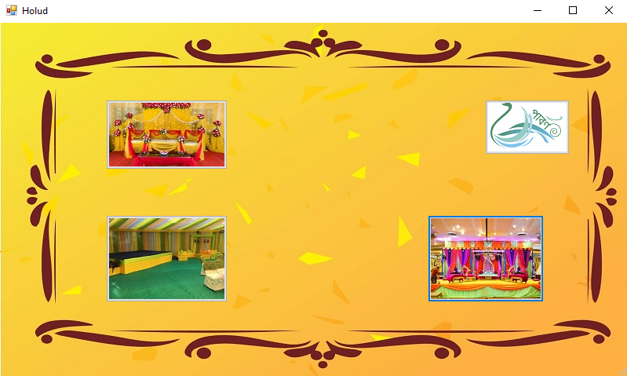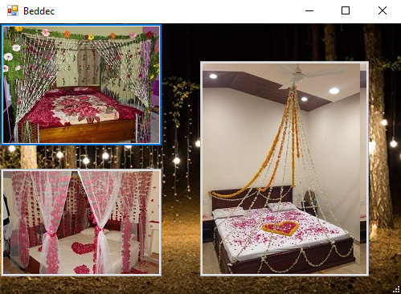

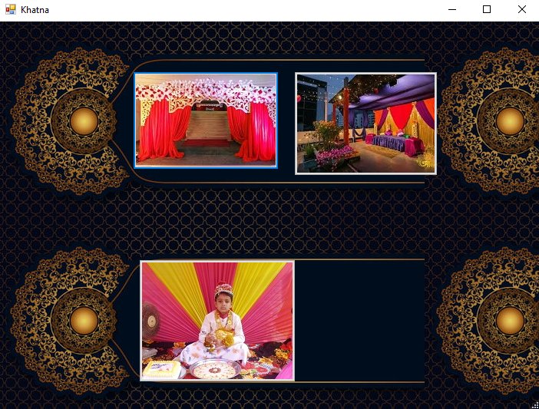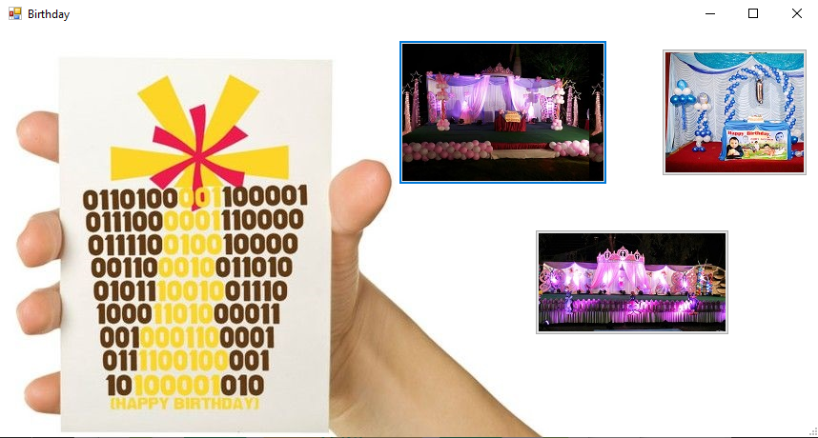

Now if you click on package booking At first page, you can select packages. Then if you click on total, you can see total price and if you confirm it then you will go to the next page, there you will fill up your information. Then if you press confirm your order will be cinfirmed and it will save in our database. This Picture are serially given below.

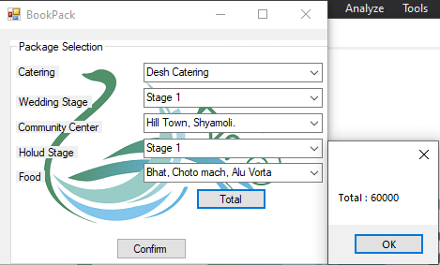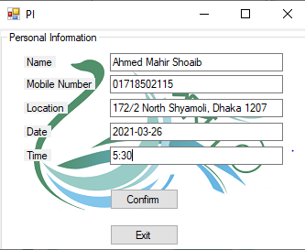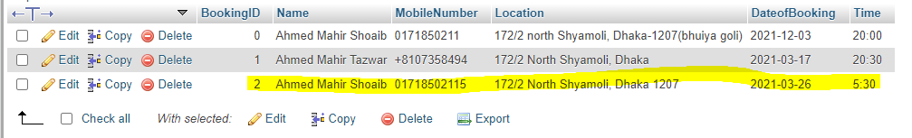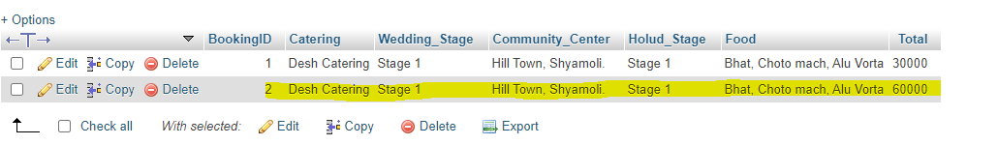

Future Plan and Conclusion:

We think that once our software is ready, it will be useful to many. Those who want to finish an event safely will definitely use this software. We also have more plans for the future with this app.

* We will add more security in our software.
* We will make our Database more secure.
* We will add online payment method.
* Also make our app more user friendly.
* We will fix all bugs. (if any)

Reference:

1. Code link: <https://github.com/amsaabesh/SDP-2-Parbon.git>
2. Image source: [www.google.com](http://www.google.com)
3. Logo: <https://www.fiverr.com/logo-maker>
4. <https://www.w3schools.com> (For Tutorials)
5. <https://www.tutorialspoint.com/csharp/> (For Tutorials)
6. [www.youtube.com](http://www.youtube.com) (For Tutorials)
7. <https://www.wikipedia.org/>
8. <https://stackoverflow.com/>
9. <https://dev.mysql.com/> (For Tutorials)